ISEM540: Homework 2 ---- Exam2 Preparation (100 points)

TOPIC: “How Did I Learn to Love Web, XML and System Integration”

IMPORTANT:
- Note: This is an individual assignment
- This assignment will be the basis of a Quiz (Exam2) as explained below.

OVERVIEW AND EXPLANATION: Completion of HW2 Assignment involves the following steps:
- Post your HW2 Report to the Discussion Forum on Date Specified. This is worth small percentage (less than 20%)
- Review the posted HW2 Reports and comment on about 2 Reports (this will earn you some extra points). The purpose is to learn from your colleagues
- Appear in a Quiz (EXAM1) that is based on HWK2. The quiz is worth almost 80% points. You will fail the Quiz if you have not done the HW2 .

The purpose of this homework is to prepare you for Exam1.

Problem 1: Middleware Concepts
- Search the Internet and identify a definition of Middleware that you like
- Compare and contrast the definition you found with the definition in the course text/slides
- According to this definition, which ones of the following are considered as middleware (put an * next to all that apply)

Router, Web Services, Payment system, HTTP, antivirus software, cookies, proxy servers, Ajax, email, operating system, Java, inventory management system, RPC, C#, CRM system, SOAP

d): Given the architectural client/server configurations in Figure 1 that show how applications can be split across computer1 (client) and computer2 (server), use the following table to answer the following questions:
- Show the middleware for each configuration .
- Which configuration will be most secure
- Which configuration will give best performance
- Which configuration will minimize the network traffic
- Which configuration is best for retail store
- Which configuration is best for mobile apps
- Supposing Computer1 is your organization’s main computer and Cmputer2 is in the cloud. Which configuration will you use and why (one sentence)?
- Which architecture is best for a retail store chain such as Walmart and why (one sentence)
- Which architectures are best for cheaper cell phones with limited capabilities (thin client or thick client)
- Which architecture is best for bank with many ATMs (bank is the server, ATMs are clients)
- Which architecture is best for a hospital system in an underdeveloped country with a very weak network and many Telemedicine centers (Hospital is the server, telemed centers are clients)

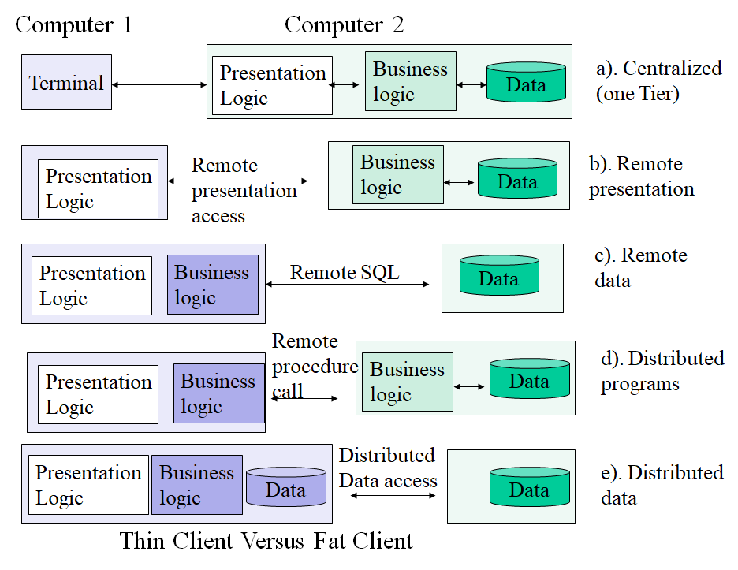
Figure 1: Architectural Configurations
 | Conf a | Conf b | Conf c | Conf d  (business logic split in middle ) | Conf e  (the data is duplicated)
1.Middleware used (e.g., RPC, RSQL)
2. Security (Low, Medium, High)
3. User Performance at Computer1 (Low, Medium, High)
4. Network traffic generated between computer 1 and computer2

Problem2: XML, Web 2.0 and Semantic Web
a) Develop a simple XML representation of a service proposed in your Project1. The objective is to show main features of your service (servicer name, location, and few other important “EA” features of this service). This document should have about 10 elements and not more than 30 statements. You should be able to exchange this information with other team members.
b). Create an XSL that shows the XML document as a table or a graphical view (e.g., a simple EA diagram) on your web browser.
c) Create a simple RSS that defines a website for your Center.
d) Add semantics to the XML document that you have created. Which technology (RDF, OWL, others) will you use and why.
e) Give a short example of how OWL can be used to represent enterprise architecture of a Center that consists of 3-5 services (this “service bundle” may be your Team Center.
f) Create a JSON representation of the XML document you created in Problem 2a
g) Compare and contrast XML with JSON. Which one do you prefer and why
h) Give two real life examples of how semantic web is being used in industry.
i) Intro to Python: Please goto www.sololearn.com and go through Module1 and Module2 to get a basic idea of Python (a highly popular language at present for AI applications)

Problem 3: Understanding System Integration and SPACE

3A: Integrated Systems
- Find one definition of architecture and one definition of integration that you like the most.
- Find one good example of an integrated system and one example of a system that is not integrated. Just give 1-2 line description of the system, its URL (if available), and reason why do you think the system is integrated or not. You can use any examples from any systems anywhere in the world.
3B: Web Services: Answer the following questions:
- What exactly is a Web Service. Explain through an Example (2-4 sentences)
- What is Amazon Web Services (AWS). Give 2 examples of how AWS could be used in your project.
- What is a REST-based Web service. Explain through 2 examples
- What is an SOA-based Web Service and how is it different from a REST-based Web Service
- What is the difference between enterprise architecture and integrated enterprise architecture (2-3 sentences)
- What roles do Web Services play in enterprise integration

3C: SPACE Experiment: Please goto SPACE ePlanner Learning Corner, go through Stage2 and Stage3 materials and answer the following questions:
- In SPACE, what is a “Bundle” and how is it used in enterprise integration.
- Can you develop a bundle for your center, just describe the steps.
- How many questions are in Stage2 Quiz
- What materials are needed in Stage3
.

Problem 4: Understanding Project2
Carefully read Project2 description and answer the following questions:

- Each team must submit one deliverable file (you need to zip multiple files into one, if needed) (True/False)
- Project2 is a continuation of Project1 in ISEM540 and requires some knowledge of SOA (True/False)
- Project2 has two deliverables (A and B) – (True/False)
- Deliverable A primarily concentrates on SOA-based Portal Design and flow of information within the portal (True/False)
- Deliverable A also requires some knowledge of Web Services (e.g., AWS) and Mobile Apps to populate the portal (True/False)
- Deliverable B requires Self Assessment by using SPACE with your login ID is required in Project2 (True/False)
- For Deliverable B, each team member will build a Service Bundle (a collection of at least two services) that represents a Unit/Section of their center by using SPACE. (True/False)

Deliverable: Upload your assignment files for all of the tasks (in .zip format) to the HWK2 Dropbox. You should include screen shots of your demos where appropriate.

Hint: www.w3schools.com provides a great deal of information on Web, XML, JSON and other web technologies.

Voice Annotated Short Tutorial on Web-XML and Semantic Web

Duration = 1 hour, URL = http://harrisburgu.adobeconnect.com/p4j3w0wgz36/

